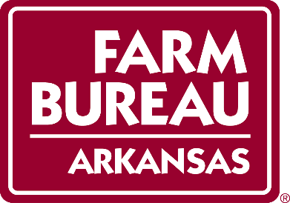

2019 STATE YOUNG FARMERS & RANCHERS COMMITTEE

Adam & Sandy Cloninger, Chair Lonoke Co District 6

Dustin Cowell, Vice Chair Newton Co District 3

Jeffrey & Julie Tubbs Craighead Co District 1

Reed Storey Monroe Co District 2

Robert & Deborah Benedict Baxter Co District 3

Jason Cranford Montgomery Co District 4

Michael & Lauren Lee Faulkner Co District 5

Price & Tiara Boney Desha Co District 6

Jamey & Sara Allen Grant Co District 7

