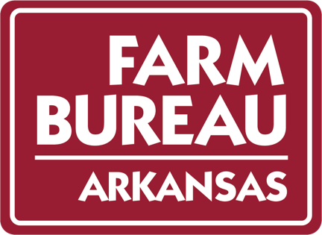

ARKANSAS FARM BUREAU FEDERATION
SWINE DIVISION
Wyndham River Front
NORTH LITTLE ROCK, ARKANSAS
JANUARY 31, 2023

1:00 p.m. Call to Order – Jason Henson, Board Liaison

Invocation/Pledge of Allegiance

Introductions

Previous Meetings Minutes

Policy Development Guidebook/ Policy

Update on board recommendations (if necessary)

1:15 p.m. Chris Cook, Entergy – Electrical Demand Charge

1:50 p.m. Swine Industry Updates
Jerry Masters – Pork Producers
Richard Gray - JBS

2:15 p.m. Discussion

Board Recommendations

Commodity Priorities

3:00 p.m. Adjourn

