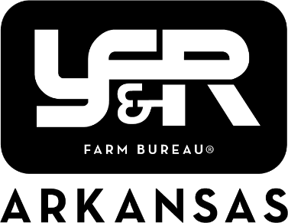

Achievement Award and Excellence in Ag 2026 Applications

The 2026 Achievement Award and Excellence in Ag applications are now available. This year the applications are web-based and must be submitted through the online platform JotForm. A “Save” option is available on the form to save your progress and return at a later time to complete. A Word form of the applications is available on the Young Farmers and Ranchers page of the ArFB website.

Instructions for Submission:
- Click the link for Achievement Award or Excellence in Ag on the YF&R page of the ArFB website.
- Either enter question answers or copy and paste answers from Word document.
- To save the form and return later:
  - Click-Save at the bottom of the form.
  - Click-Skip Create an Account.
  - One the next screen you will see: Your form has been saved as a draft. Enter your email and a link will be emailed to you. This link will be needed to continue the form at a later time.

*We always recommend typing your answers on the Word document and saving to your computer, and then copying and pasting into the form, to avoid losing any of your entry. It is also recommended to familiarize yourself with the JotForm site before the deadline in case you have any issues.

